11th October
Embargoed until 24th October 2022.
The Schools’ Challenge Takes Off!
Lincolnshire Agricultural Society’s Schools’ Challenge 2023
The Schools’ Challenge – held annually by the Lincolnshire Agricultural Society has launched! Every school and early years establishment in Greater Lincolnshire and beyond has been invited to get involved. With ten fantastic challenges to choose from, providing both fun and lots of enrichment opportunities, this is one competition not to be missed!
The challenges are themed around food, farming, the local community, the environment and sustainability, and focus on inspiring young minds to gain a better understanding of Lincolnshire’s rich history, its horticulture and land-based activities, whilst putting learning into context.
The challenges are all student-led and encourage them to research their ideas and present their findings, ultimately at the Lincolnshire Show itself on 21st and 22nd June 2023! Schools can select a long or short-term project to complete, and each challenge can easily be adapted to suit any age group.
Schools are also offered the opportunity to incorporate the help of an ambassador from the farming or business background, who will provide support and expert knowledge along the project journey, whichever challenge they choose.
“Thank you for such a super event. Our pupils really loved it all, and they got so much out of it. It was all really well organised, and we will definitely be doing it again.” University Academy Holbeach.
If you would like more information on the Schools’ Challenge competition, contact Suzy Stone at the Lincolnshire Showground:
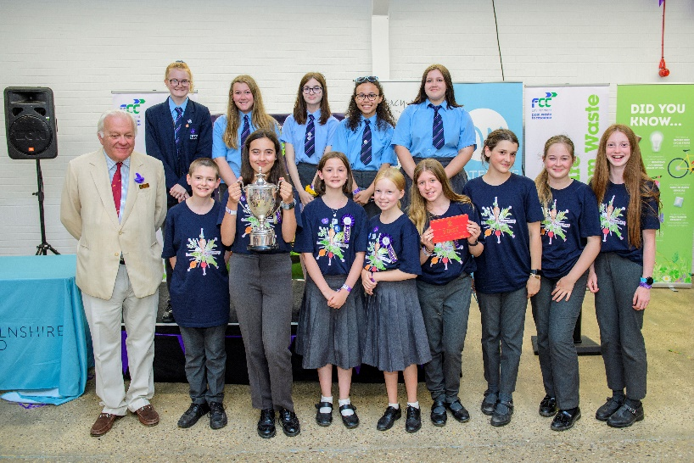
sstone@lincolnshireshowground.co.uk
01522 585502
(Enc).
#schoolschallenge23
@LASEducation
(Further pictures available on request)

