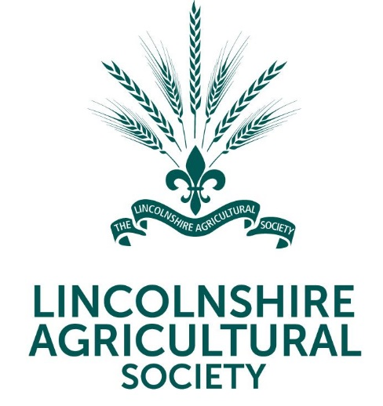 | 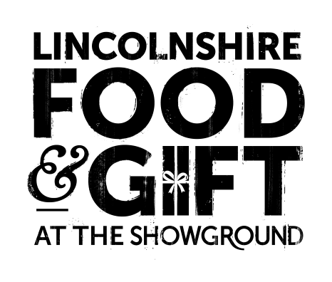
News Release

16th November 2023

The Countdown Begins for the Lincolnshire Food & Gift Fair

Thousands are expected to descend on the Lincolnshire Showground in nine days’ time for the annual Food & Gift Fair on 25th and 26th November.

With over 150 stalls selling everything from baubles to beer, live performances by local choirs and festive fun for the kids, it’s a day out for the whole family to enjoy.

As well as the opportunity to buy some unique gifts ahead of the big day, visitors who have booked onto one of the Adult Festive Workshops will be able to make their own Christmas wreath, door swag or table decoration with expert tuition from the Lincolnshire Co-op floristry team.

For the younger visitors, Santa Claus will be stopping by to read a Christmas-themed story and hand out presents to the children as part of the Storytime with Santa experience which is new for this year and includes milk and cookies.

The Great British Bake-off contestant Sandy Docherty will also be making an appearance, along with Dominic Franks of Dom in the Kitchen fame and other well known local chefs in the Lincolnshire Kitchen. Children will be able to bake their own tasty treats and have a go at Christmas arts and crafts in Santa’s Workshop & Bakehouse.

Lincolnshire Agricultural Society Chief Executive Charlotte Powell said: “Many people will be looking for an alternative to the Lincoln Christmas Market this year, so the Food & Gift Fair provides a great opportunity for shopping for unique gifts and to get into the Christmas spirit.

“This year’s fair promises to be a bumper event and at £5.50 per person (plus booking fee) when you book in advance online, it’s amazing value for money!

“Lots of local and regional businesses, who usually have a stall at the Christmas market, have also taken up the opportunity to have a stall at the Food & Gift Fair, in fact we have several exhibitors this year who are coming for the first time which we’re really excited about.

“These include A.W. Robinson Furniture, Blueberry, Jane Haigh Country Art, R. G. Taylor & Sons, Scandigifts, Barkworth Reeve, The Silver Spring Jewellery and The Uplift Grazing Ltd.”

Tickets for the Lincolnshire Food & Gift Fair cost £5.50 (plus a booking fee) in advance up to 23:00 on 24th November from lincolnshireshowground.co.uk/food-gift or £7.00 on the door. Children under five and parking are free.

Storytime with Santa costs £8 per child (plus a booking fee). All children must be accompanied by an adult. One adult is free, and tickets for additional adults cost £3 each (plus a booking fee). Adult Festive Workshop prices start from £40.50 (plus booking fee) and include entry to the Food & Gift Fair.

For more information, please visit lincolnshireshowground.co.uk/food-gift

Ends

Notes to Editors
About the Lincolnshire Showground
- The 270-acre Lincolnshire Showground is owned by the Lincolnshire Agricultural Society (LAS) which was formed in 1869 and celebrated its 150th anniversary in 2019.
- As a charitable organisation its objectives are to educate the county about food, farming and a sustainable environment. 100% of surplus funds from events are gift aided back into the charity to deliver the charity’s educational work.
- For more information, about the LAS or Lincolnshire Showground please visit lincolnshireshowground.co.uk

For media enquiries please contact:
Kate Strawson
Director
Shooting Star
kate@weareshootingstar.co.uk
01522 528 540 / 07733 230 293

